

Web Application User Manual

The a Team

XBCAD7319 | Work Integrated Learning | 25/11/2024

Table of Contents

Why was the application created 3

App Features: 3

Employee Management 3

Onboarding 3

Requests 3

Performance 3

Analytics 3

Flow of the Application: 4

Diagram: 4

Login 5

Dashboard 6

Employee Management 7

Edit employee details 7

Edit Personal Information 8

Edit Job Details 9

Edit Uploaded Documents 10

Edit Payroll Information 11

Reset Password 12

Release Payslips 13

Release Payslips (Continued) 14

Incident Reporting 15

Leave Requests 16

Overtime Requests 17

Analytics 18

Onboarding 19

Personal Information 19

Job Details 20

Upload Documents 21

Payroll Information 22

Successful Message: 23

Create Review 24

List of Reviews 25

Create Training 26

List of Trainings 27

Final Notes and Support 27

# Why was the application created

The SparkLine HR platform was created to solve the problem that SparkLine Finance has of currently using paper-based systems to track employee information. The web app contribution to this platform is to allow HR to view information about the employees that have been onboarded, as well as performing tasks such as request accepting or declining, performance review posting, training course posting, and pay slip release. The HR employees are also able to view performance metrics for specific employees, as well as the metrics for employee hiring processes.

# App Features:

## Employee Management

This feature will allow HR to view a list of current employees with details about each user, and also edit the details of the users. The HR will have the option to release pay slips on the 25th of every month for each employee, and will be able to view incidents that have been reported through the android app.

## Onboarding

This feature will allow HR to onboard new employees by inputting their personal information, job details, all necessary documents as well as banking information for the payroll of the employee that is being onboarded. Once an employee is onboarded, they will receive an email with an OTP which will be used to log into the Android application.

## Requests

This feature will allow HR to view leave requests and overtime requests that have been submitted by the employees through the android app. HR can view any documents that have been uploaded with the leave requests and can view the details of both leave requests and overtime requests. HR will then be able to approve or decline each request individually.

## Performance

This section will allow HR to create performance reviews and post training courses for employees. The HR will have to enter the details for the reviews and training courses that the user can view. The HR web app is also able to view the information about all past reviews and courses uploaded for all employees, and they will be able to search through these past uploads.

## Analytics

In the analytics sections, HR has the ability to view a bar graph showing the number of employees that have been onboarded to the company within a yearly frame. Secondly, the line graph can be filtered to show all of the ratings given to an employee in all of their performance reviews throughout their tenure at the company.

# Flow of the Application:

## Diagram:

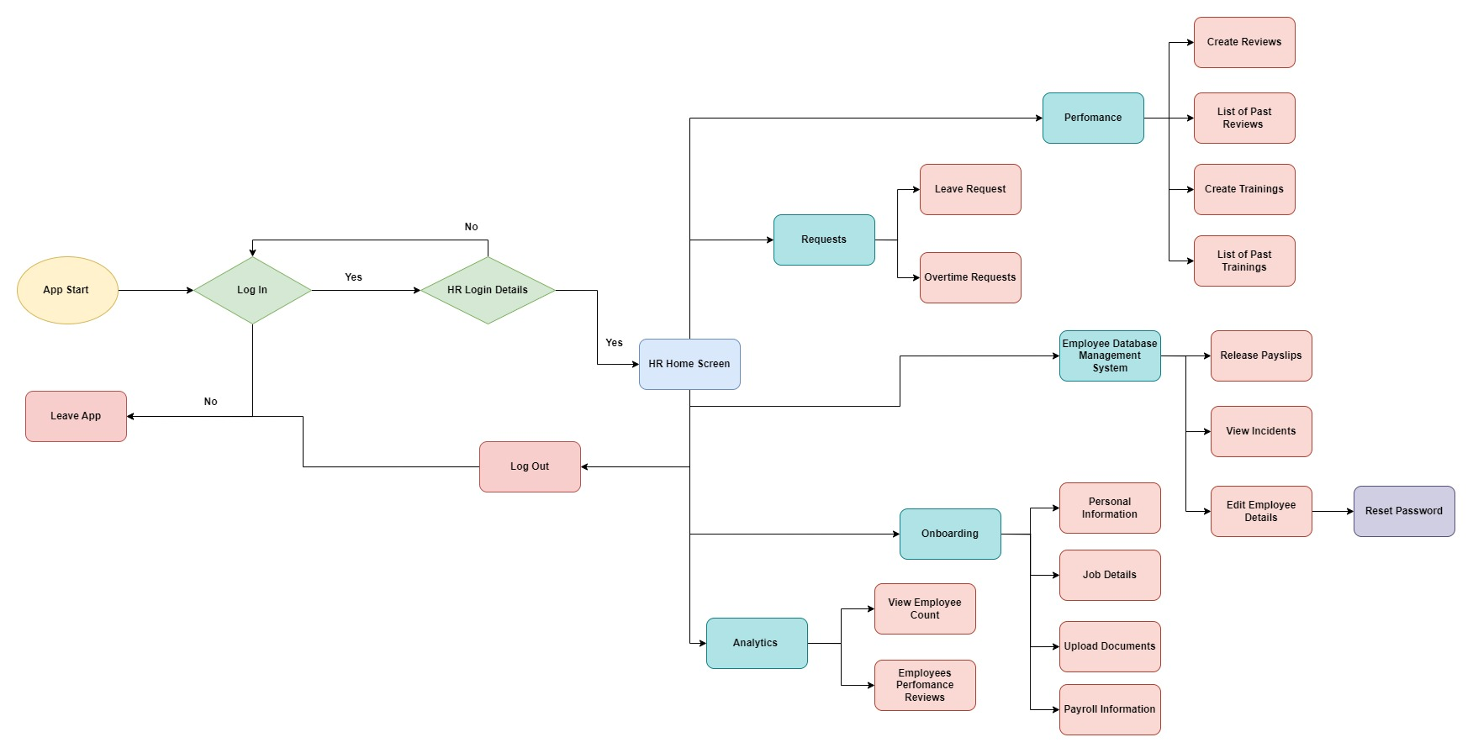

Figure 1: Flow Diagram of the HR Web Portal (drawn on draw.io)

## Login

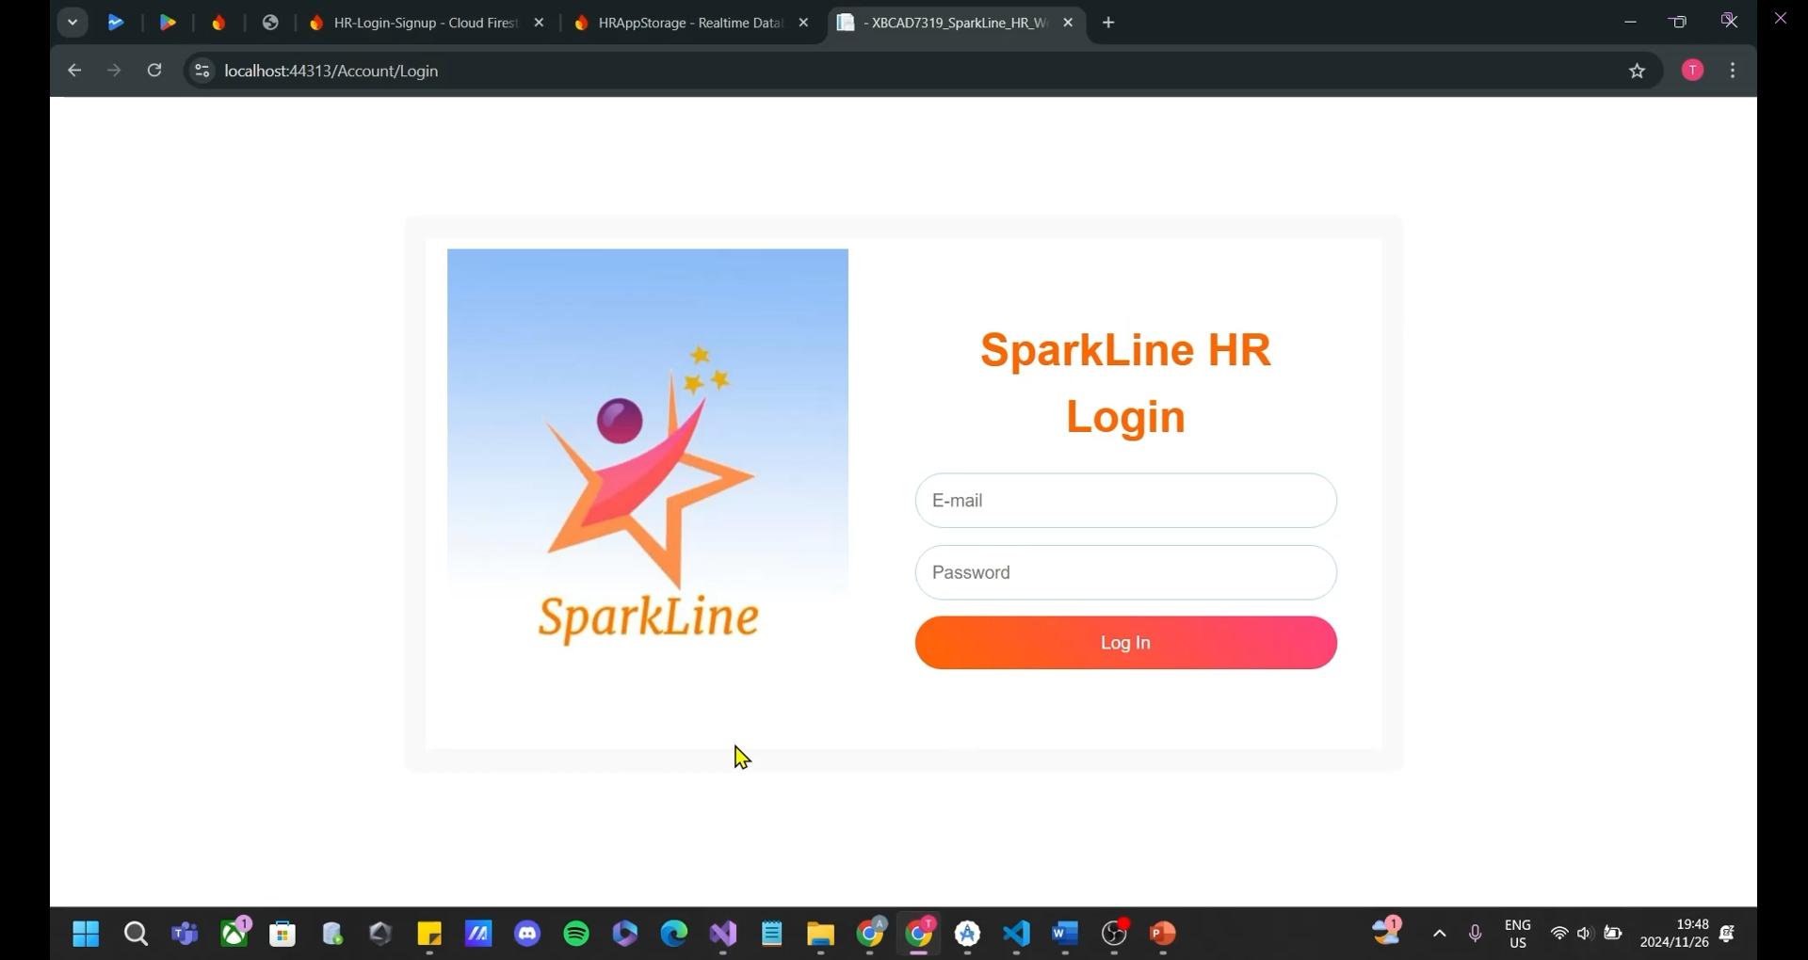

Figure 2: Login Screen (SparkLine, 2024)

Figure 2: This screen will display when the HR first starts the application. They are prompted to log into the application by using their company email address as well as their password and click the “Log In” button.

## Dashboard

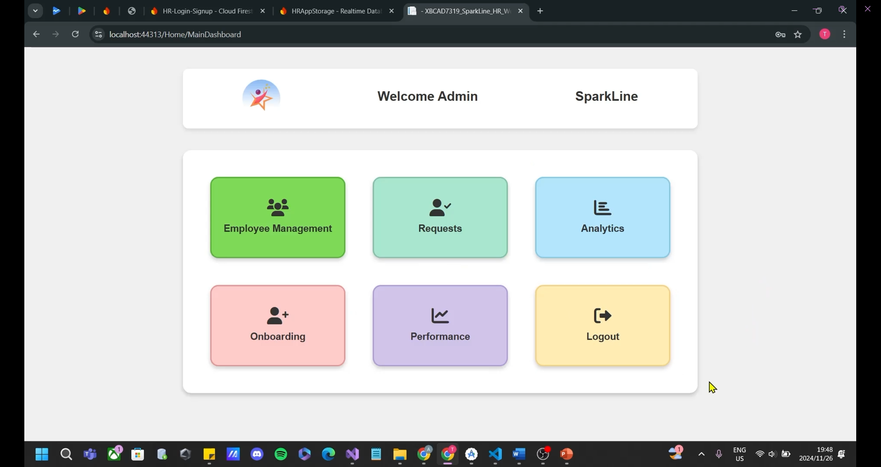

Figure 3: Dashboard (SparkLine, 2024)

Figure 3: This screen displays after the HR logs into the application. They are provided with 6 options, namely: “Employee Management”, “Requests”, “Analytics”, “Onboarding”, “Performance” and a “Logout” button.

## Employee Management

### Edit employee details

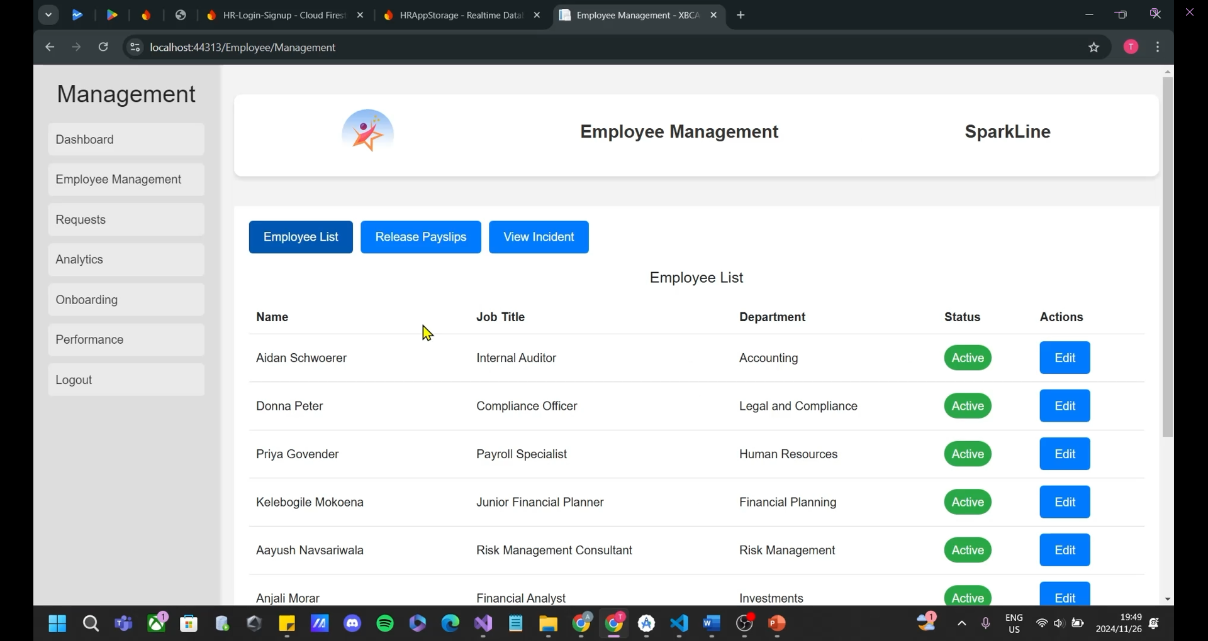

Figure 4: Employee Management - Employee List (SparkLine, 2024)

Figure 4: When “Employee Management” is selected, the HR is directed to this screen where they can view all employees of the company as well having the option of editing any employee’s information by clicking on the “Edit” button.

### Edit Personal Information

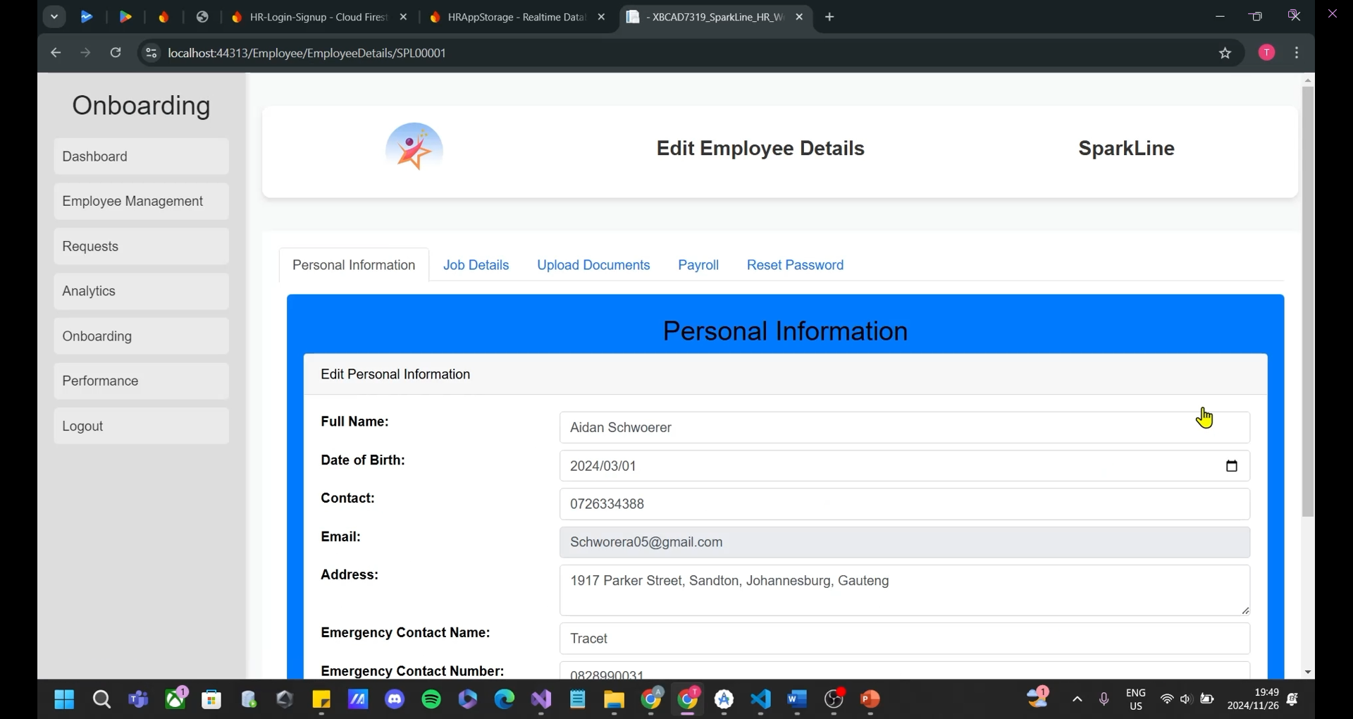

Figure 5: Edit - Edit Personal Information (SparkLine, 2024)

Figure 5: When the “Edit” button is selected in “Employee Management”, the HR is directed to this screen where they can view all of the personal information of the employee they chose to select. Here, they can edit all of the personal information of that selected employee.

### Edit Job Details

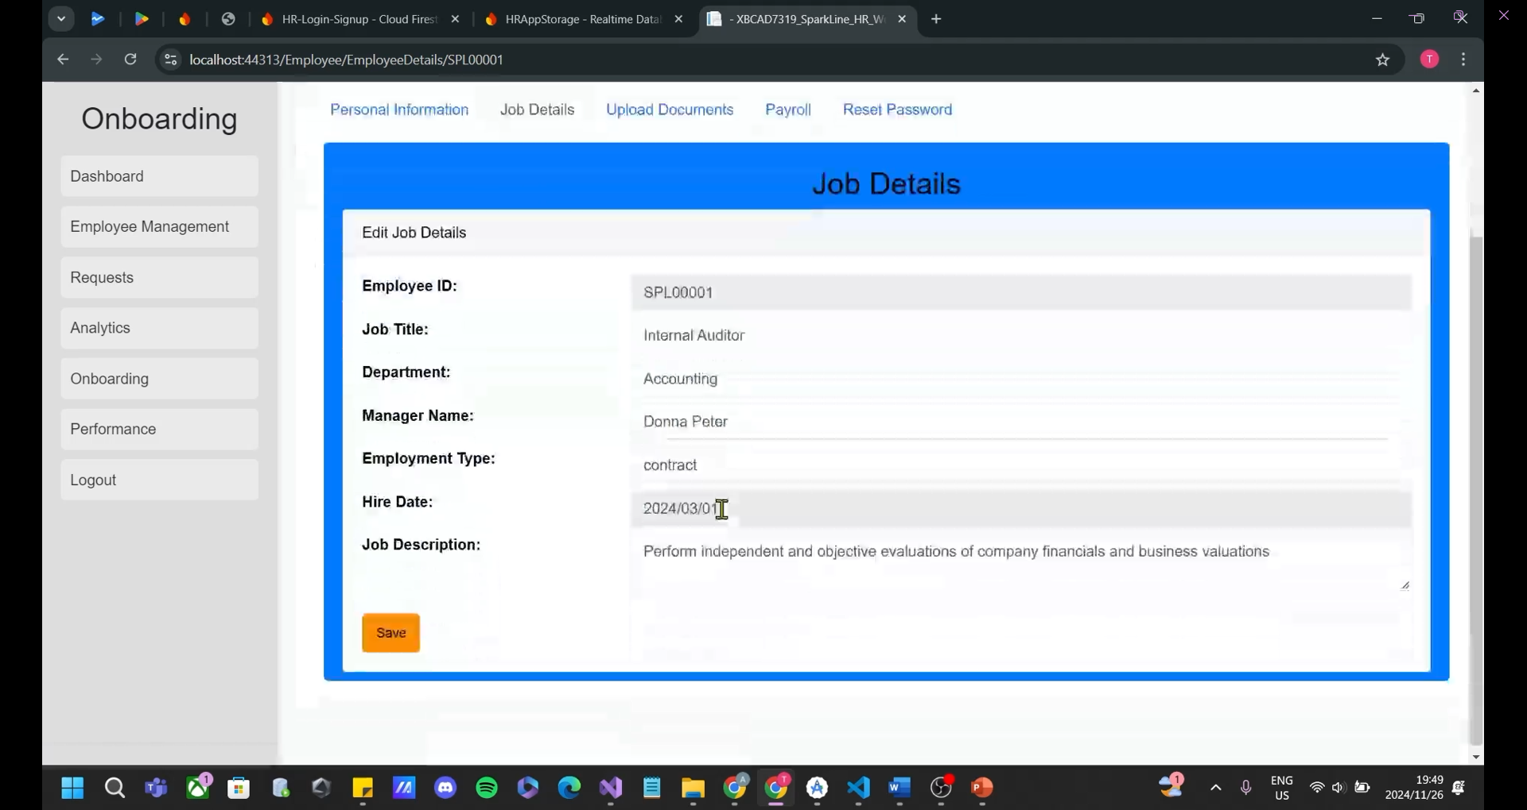

Figure 6: Edit - Edit Job Details (SparkLine, 2024)

Figure 6: The “Job Details” tab will show the job details of the selected employee and the HR can edit all of their job details with the exception of their employee number and hire date.

### Edit Uploaded Documents

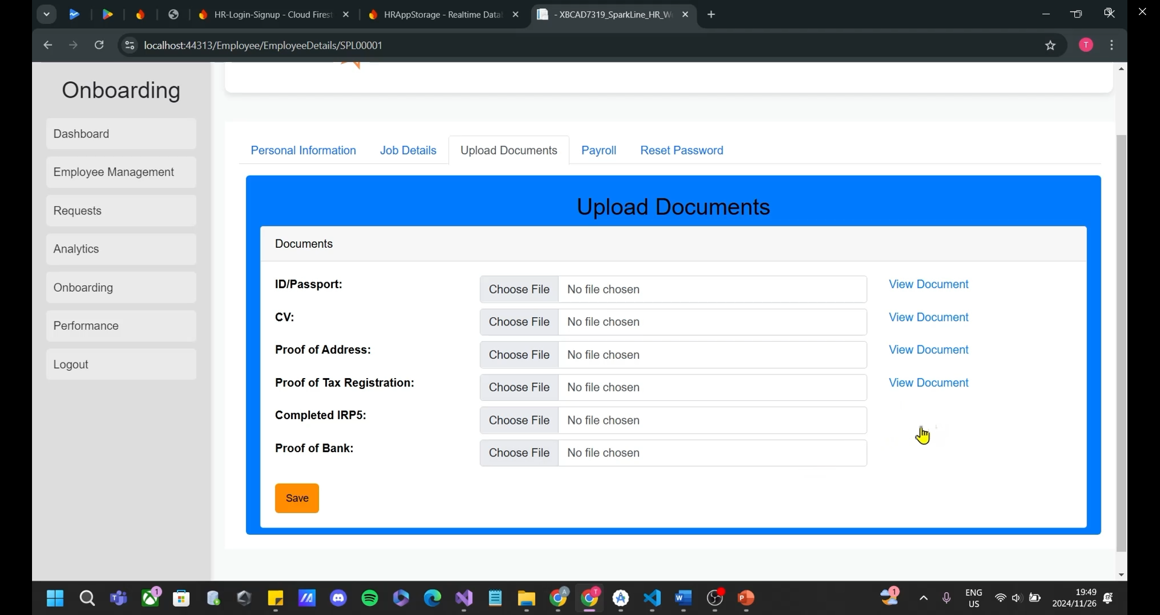

Figure 7: Edit - Edit Uploaded Documents (SparkLine, 2024)

Figure 7: When the “Upload Documents” tab is selected, the HR can upload, view or replace any document regarding the employee that they are currently viewing by clicking on the “Choose File” to upload or replace a document and click on “View Document” to view the current document that has been uploaded.

### Edit Payroll Information

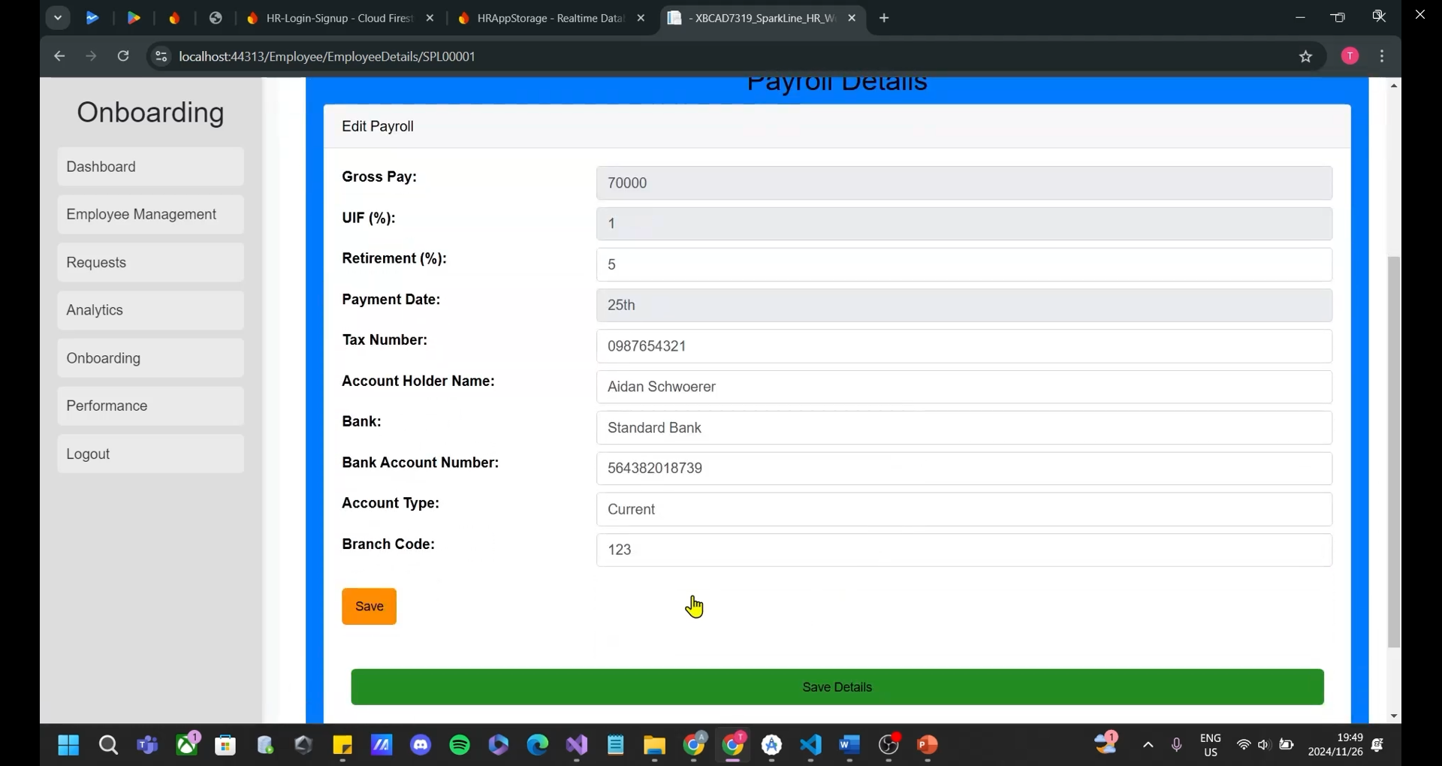

Figure 8: Edit - Edit Payroll Information (SparkLine, 2024)

Figure 8: When the “Payroll” tab is selected, the HR is directed to this screen where they can view all of the personal information of the employee they chose to select. Here, they can edit all of the personal information of that selected employee.

### Reset Password

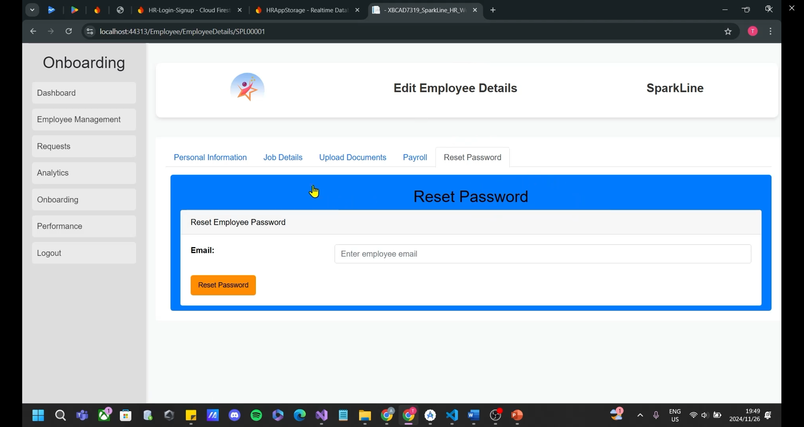

Figure 9: Edit - Reset Password (SparkLine, 2024)

Figure 9: When the “Reset Password” tab is selected, the HR can enter the email address of an employee who wants their password to access the Android application to be reset. Once that has been done, the employee will receive an email with their new OTP for a password change in the Android application.

### Release Payslips

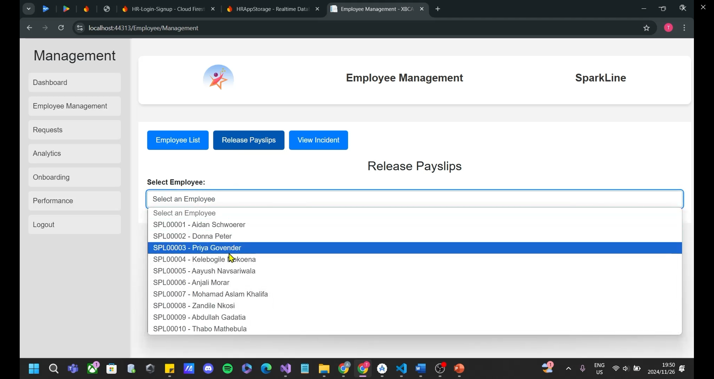

Figure 10: Employee Management - Release Payslips (SparkLine, 2024)

Figure 10: In the “Employee Management” screen, the “Release Payslips” tab allows HR to select an employee from the list of employees in the company from a dropdown menu.

### Release Payslips (Continued)

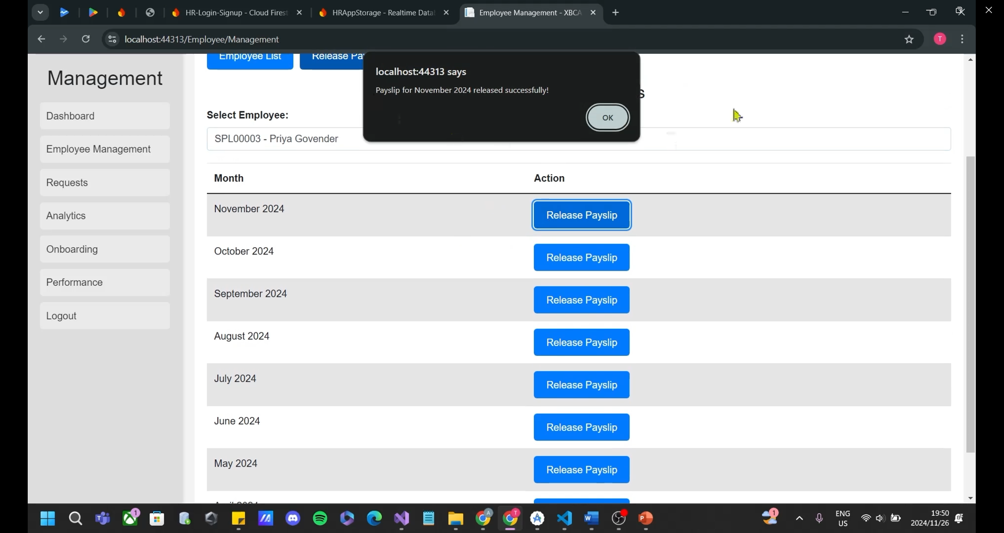

Figure 11: Employee Management - Release Payslips (Continued) (SparkLine, 2024)

Figure 11: After selecting an employee from the dropdown menu, the HR can (from the 25th of every month) release a payslip to the employee for that month by clicking on the “Release Payslip” button. This payslip can be viewed by the employee in their Android application.

## Incident Reporting

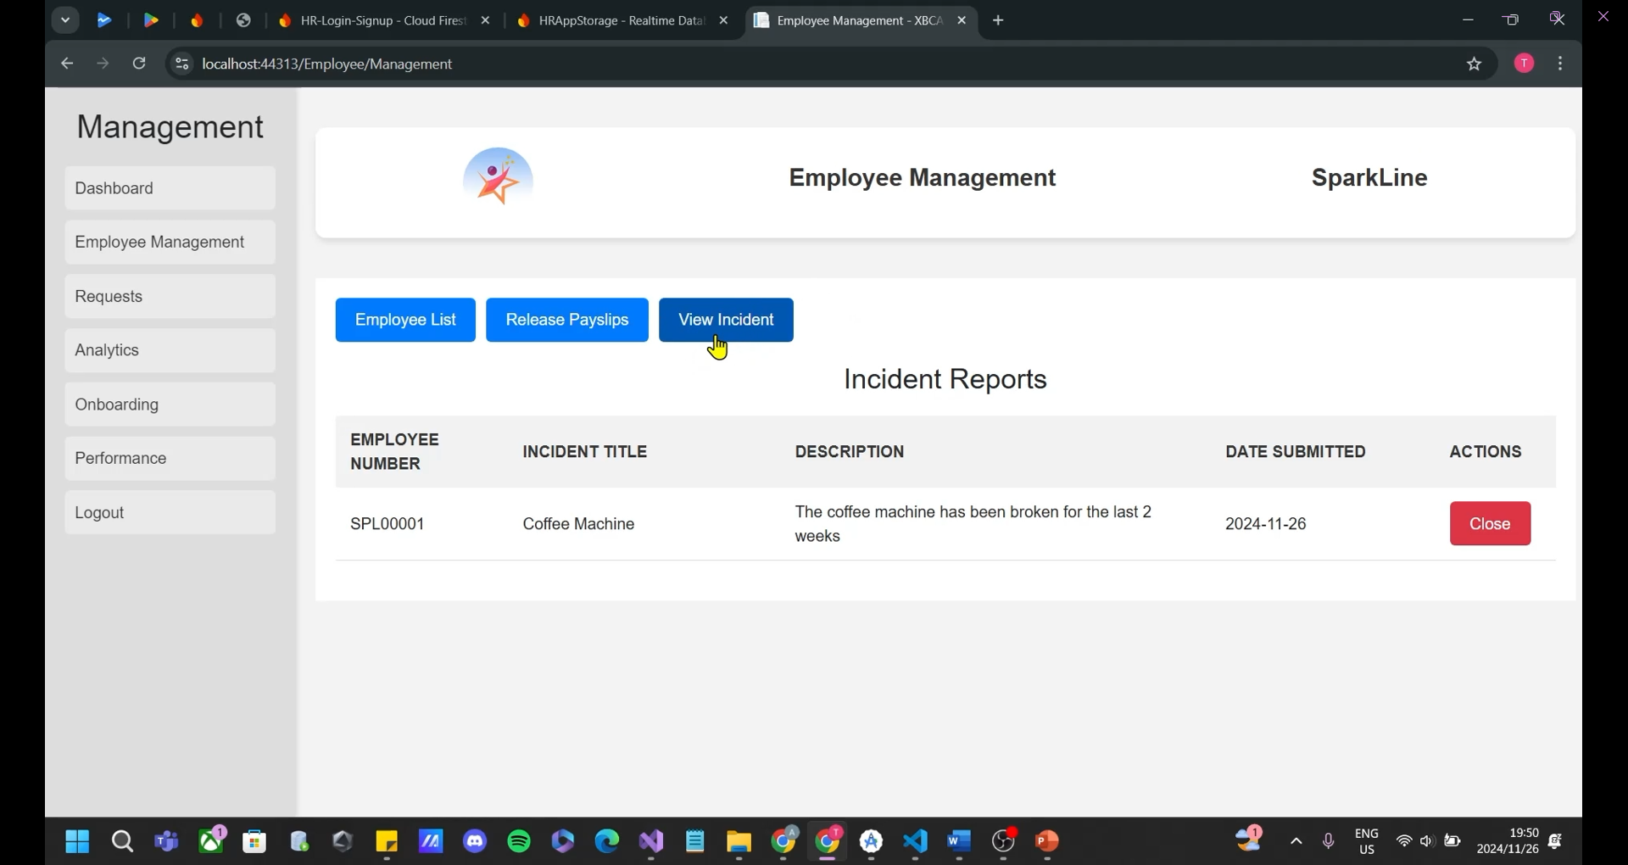

Figure 12: Employee Management - Incident Reporting (SparkLine, 2024)

Figure 12: In the “View Incidents” screen, the HR can view all incidents submitted by employees either anonymously or with their employee number. Once the HR has resolved a particular incident, they can click the “Close” button and the incident will be removed.

## Leave Requests

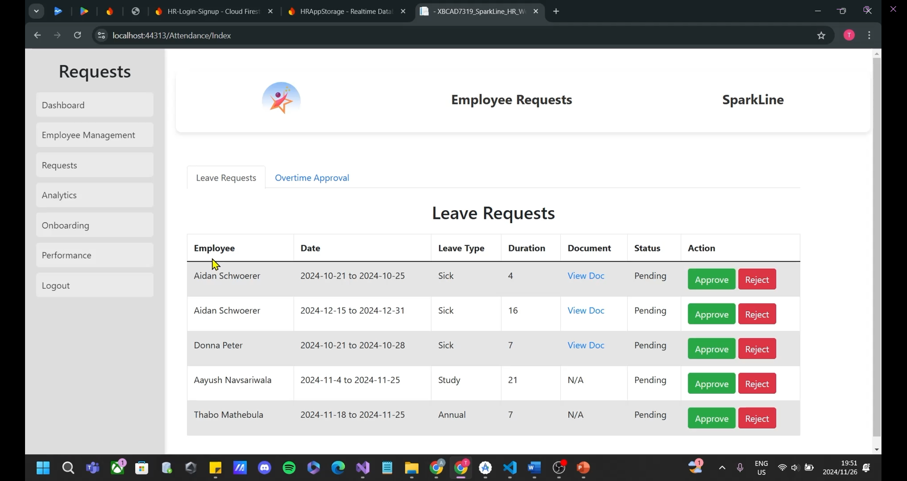

Figure 13: Requests - Leave Requests (SparkLine, 2024)

Figure 13: In the “Requests” section, the HR will be shown the pending leave requests and for sick requests, they can view the sick note by clicking the “View Doc” button. To approve or reject a leave request, the HR can select one of them and that request will be removed from the list.

## Overtime Requests

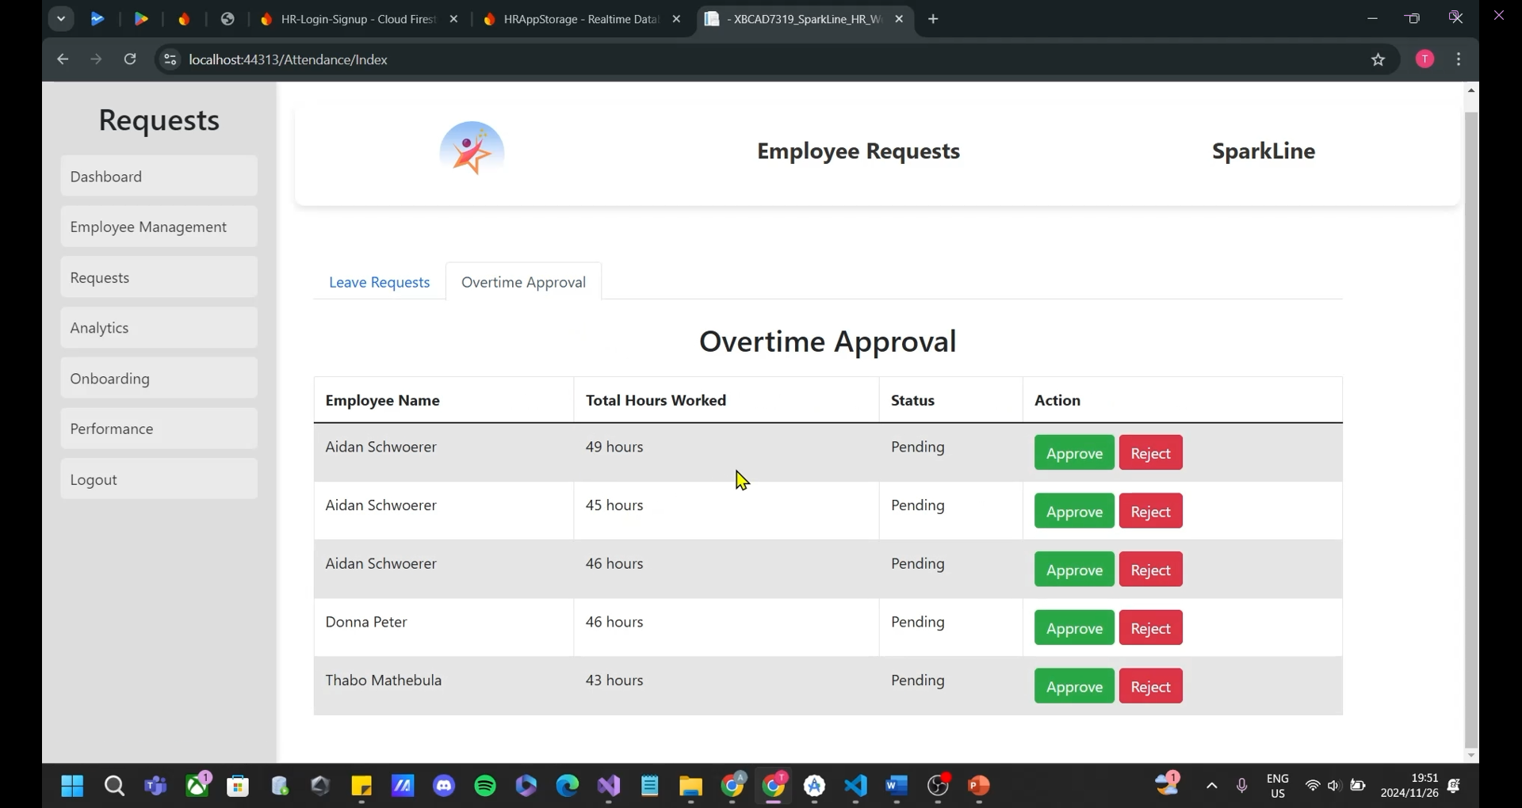

Figure 14: Requests - Overtime Approval (SparkLine, 2024)

Figure 14: In the “Overtime Approval” tab, the HR has the ability to view all overtime requests made by employees. Using the “Approve” or “Reject” buttons will remove the request from the list and be updated on the employee’s Android application.

## Analytics

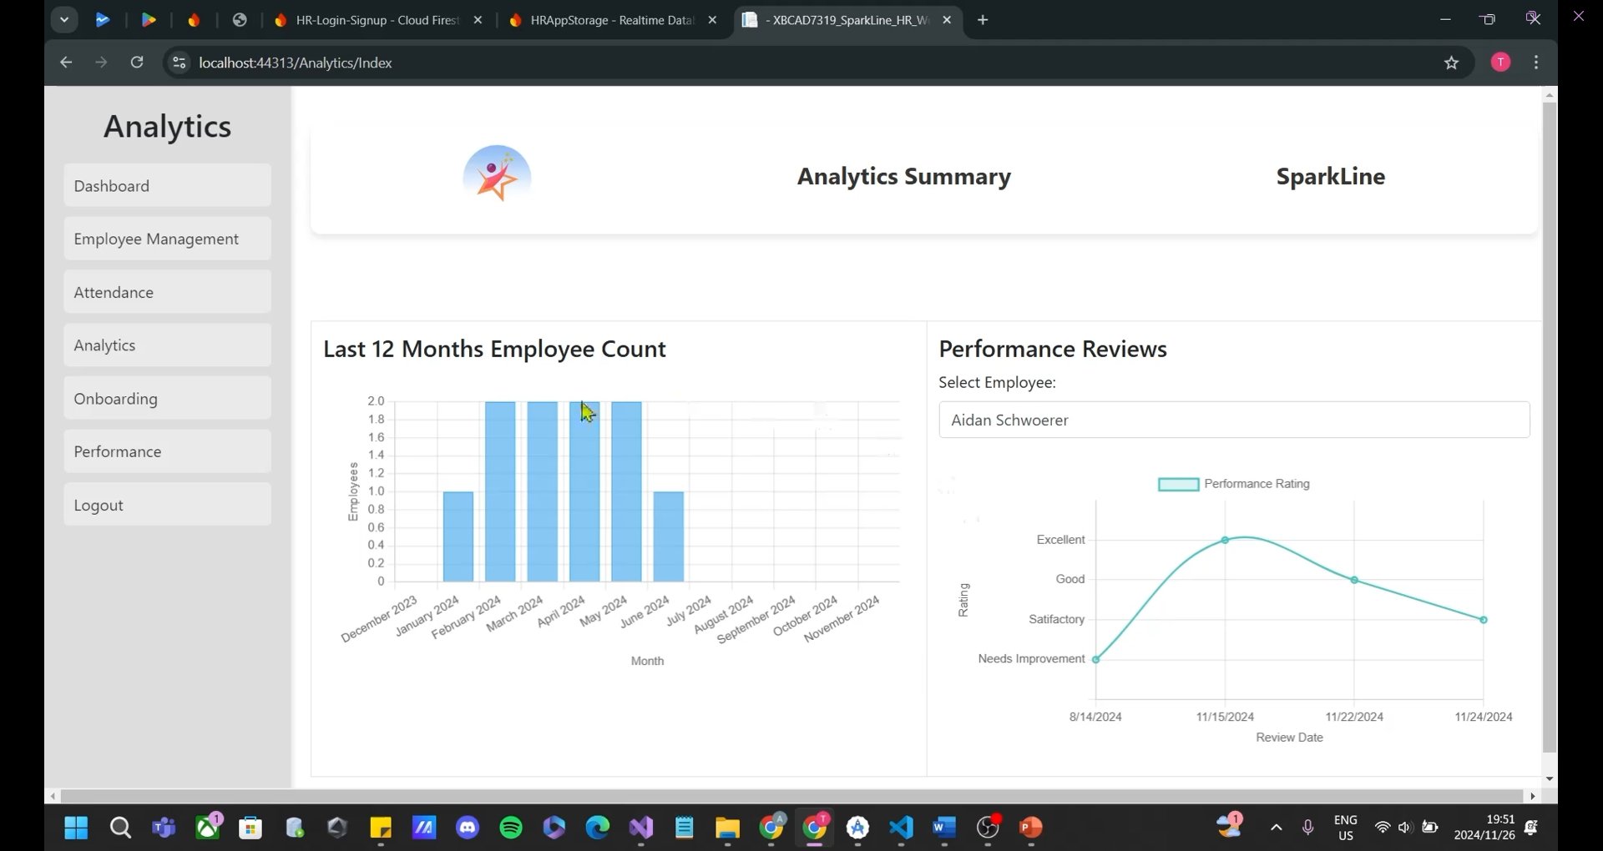

Figure 15: Analytics (SparkLine, 2024)

Figure 15: In the “Analytics” screen, the HR can view analytics relating to the company with the bar graph which shows the number of employees that were hired in a particular month of the year by the company. In the second graph (line graph), the HR can select an employee from the dropdown list and the graph will be populated with all of the performance ratings the selected employee has received over the time of them being at the company.

## Onboarding

### Personal Information

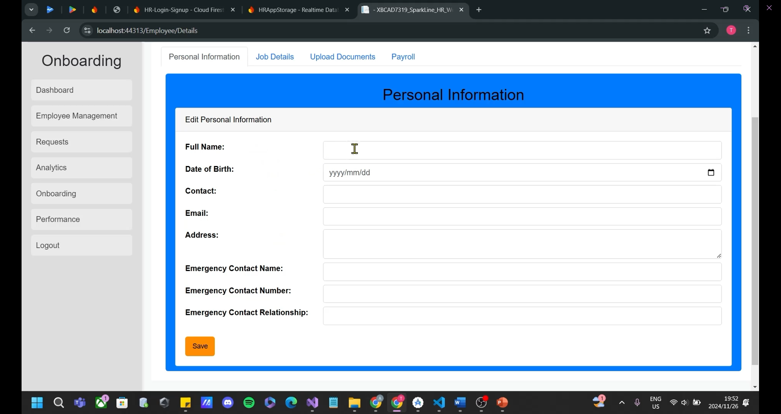

Figure 16: Onboarding - Personal Information (SparkLine, 2024)

Figure 16: In the “Onboarding” screen, the HR can onboard a new employee by inputting their full name, date of birth, contact number, email address, residential address, emergency contact name, emergency contact number and select from a dropdown menu the emergency contact’s relationship to the employee. Once done, the HR can click the “Save” button and select the “Job Details” tab to carry on the onboarding process of the new employee.

### Job Details

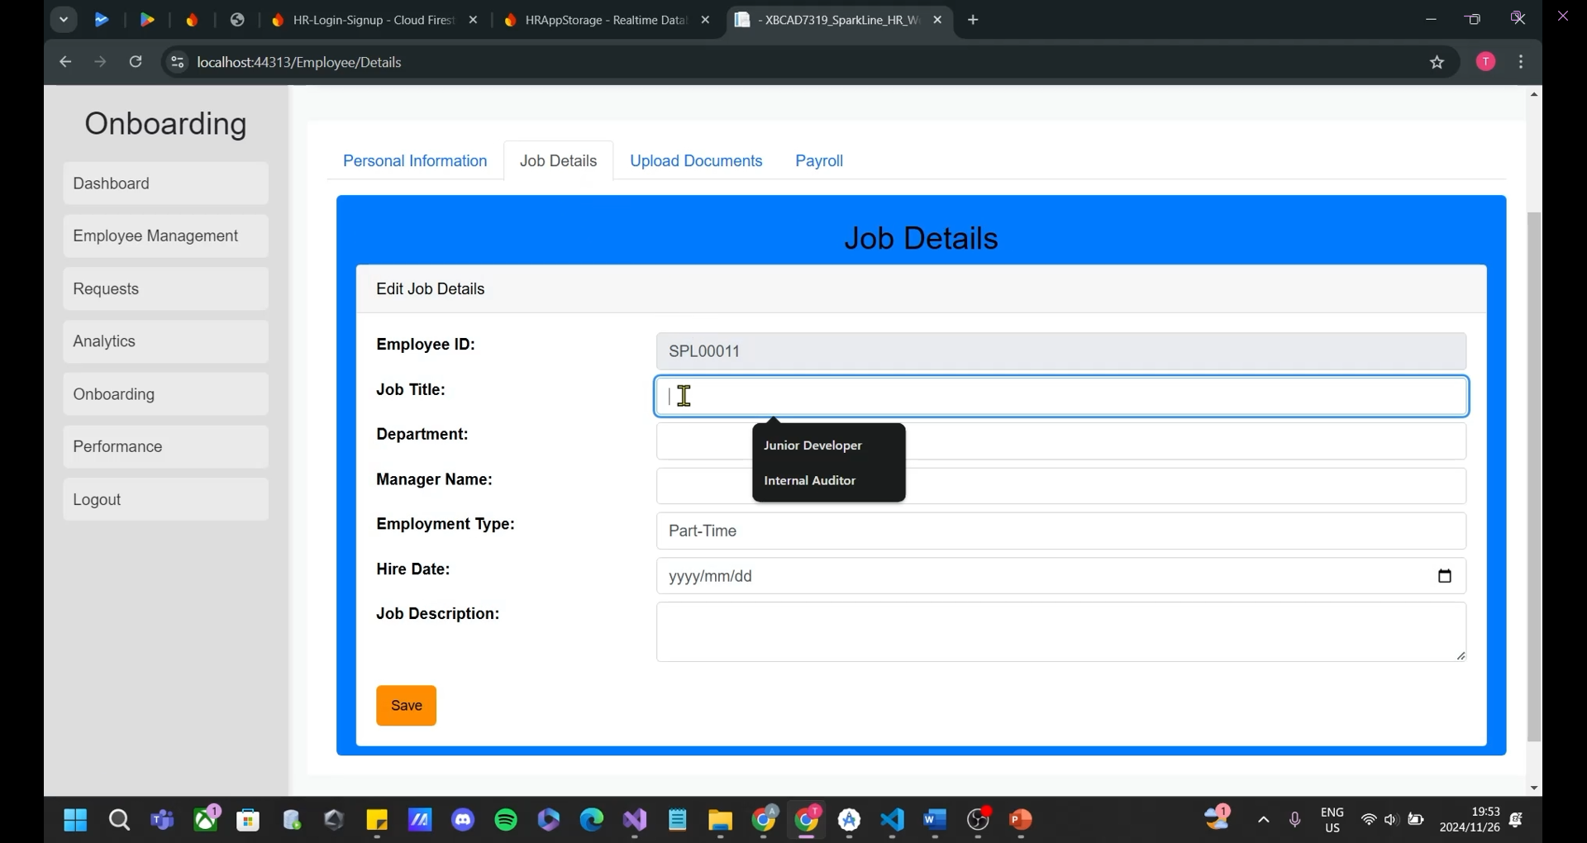

Figure 17: Onboarding - Job Details (SparkLine, 2024)

Figure 17: In the “Job Details” tab, the HR can input the job title, department, manager name, employment type, hire date and job description of the employee they are onboarding. The employee number will be automatically generated by the system and is therefore non-editable. Once done, the HR can click the “Save” button and select the “Upload Documents” tab to carry on the onboarding process of the new employee.

### Upload Documents

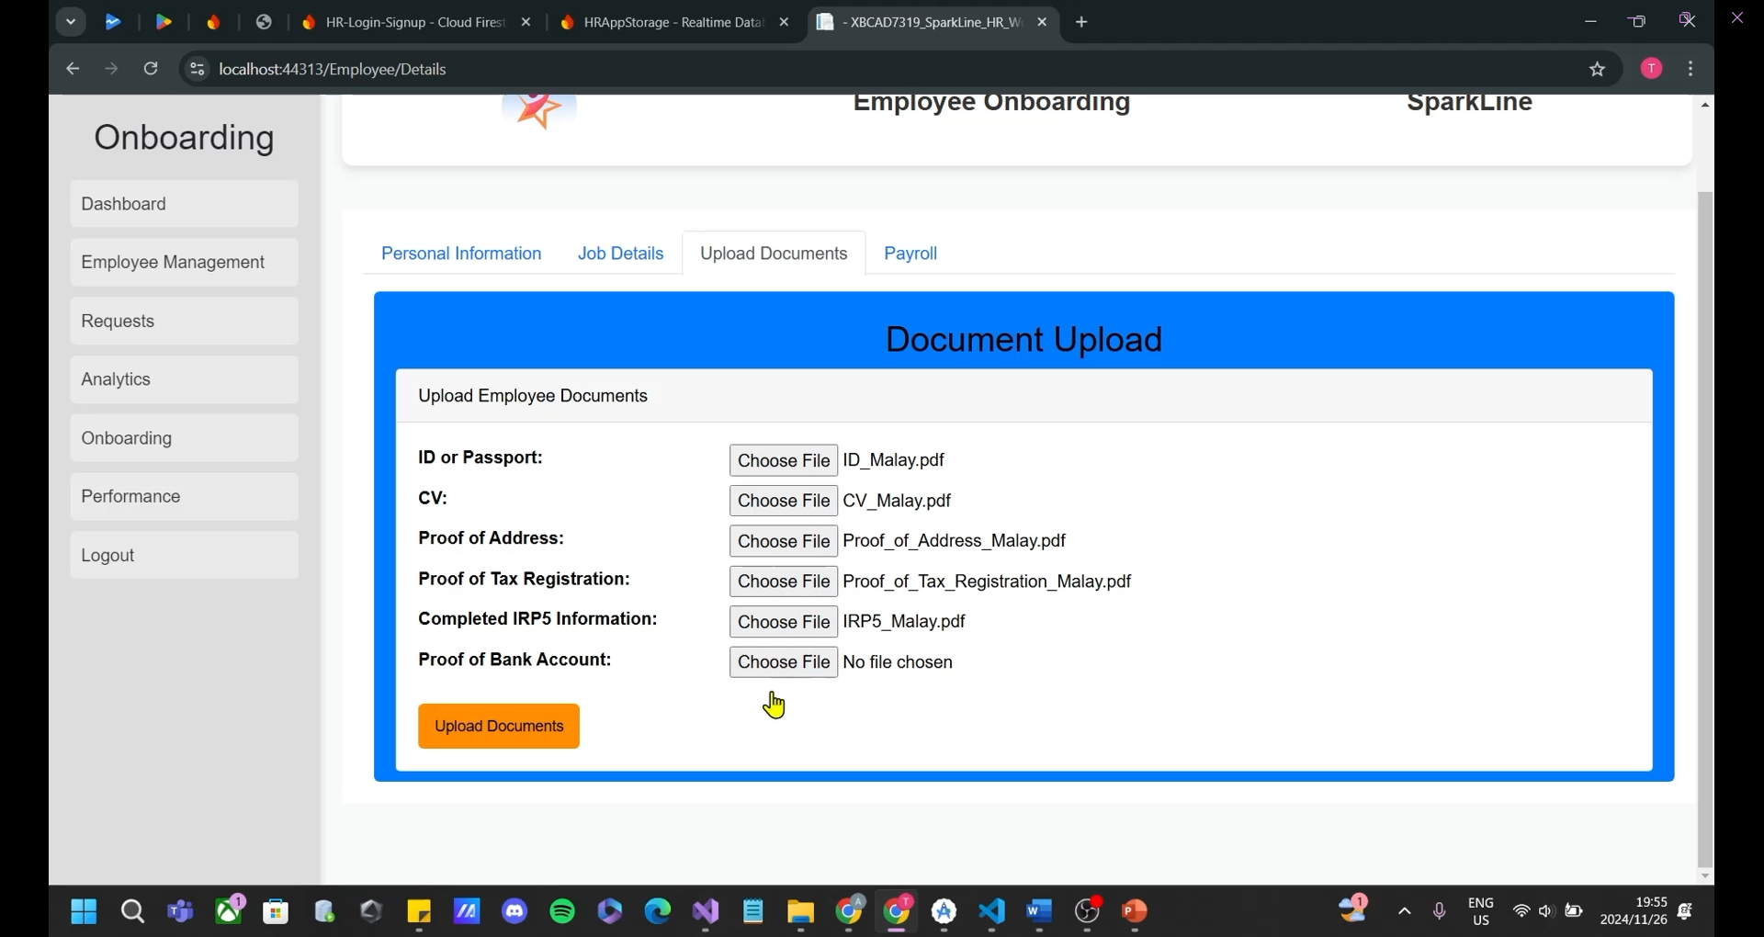

Figure 18: Onboarding - Upload Documents (SparkLine, 2024)

Figure 18: In the “Upload Documents” tab, the HR can upload the ID or passport, CV, proof of address, proof of tax registration, completed IRP5 information and proof of bank account for the employee being onboarded. Once done, the HR can click the “Upload Documents” button and select the “Payroll” tab to carry on the onboarding process of the new employee.

### Payroll Information

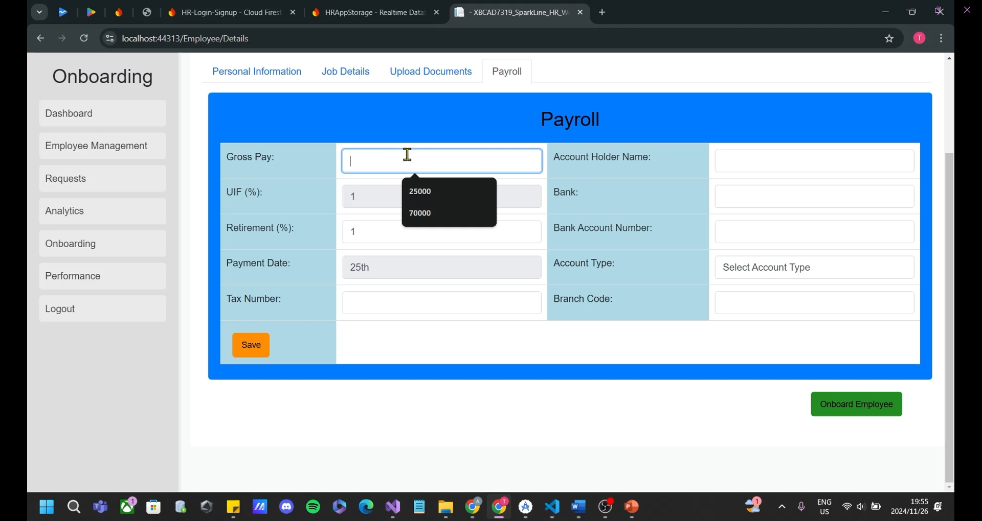

Figure 19: Onboarding - Payroll (SparkLine, 2024)

Figure 19: In the “Payroll” tab, the HR can input the gross pay, retirement percentage, tax number, account holder name, bank, bank account number, select the account type and input the branch code of the employee they are onboarding. The UIF percentage will follow the assumption that all employees will contribute 1% of their salaries and is therefore, non-editable. Secondly, the company will pay employees on the 25th of every month following the industry standard and is therefore, non-editable. Once done, the HR can click the “Save” button and then select the “Onboard Employee” button.

### Successful Message:

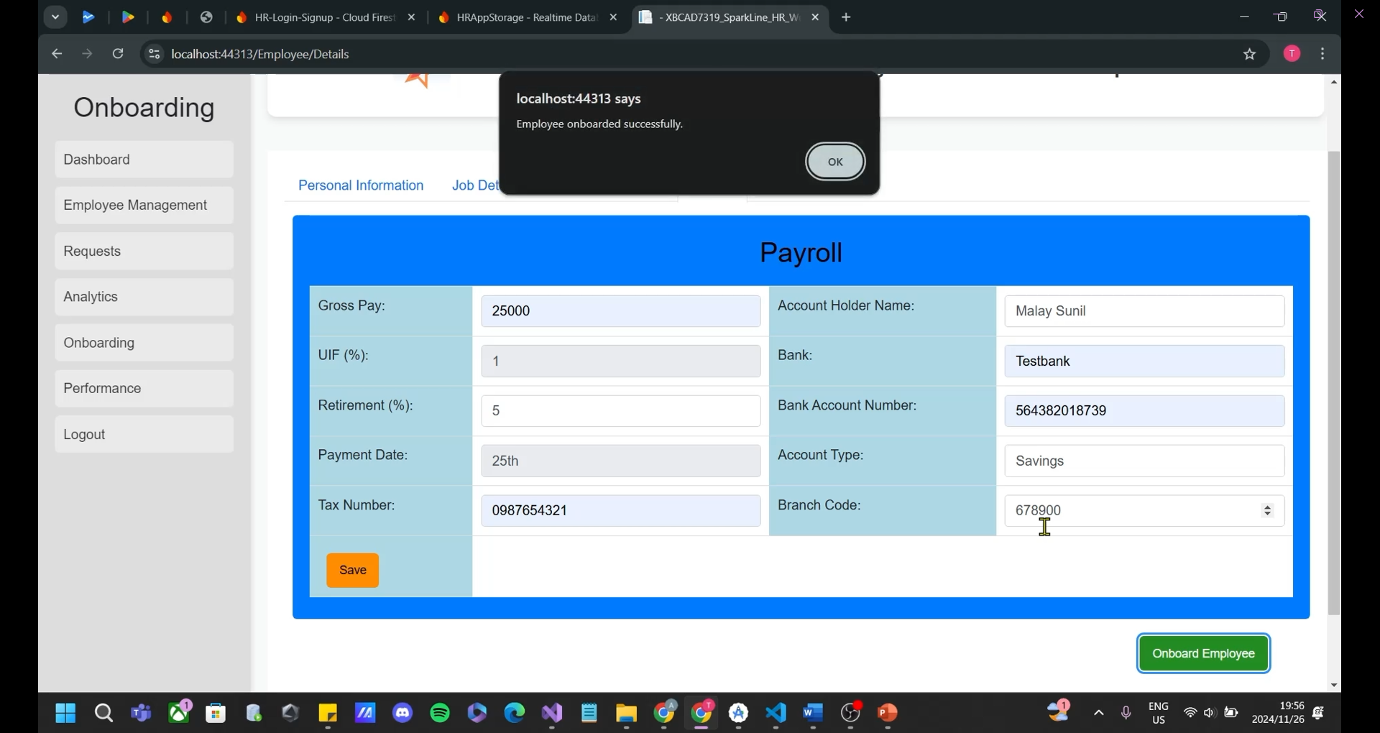

Figure 20: Onboarding - Success Message (SparkLine, 2024)

Figure 20: Once the “Onboard Employee” button has been clicked, the HR will receive a pop-up message showing that the onboarding was successful and the new employee will receive their OTP to log into the Android application via email.

## Create Review

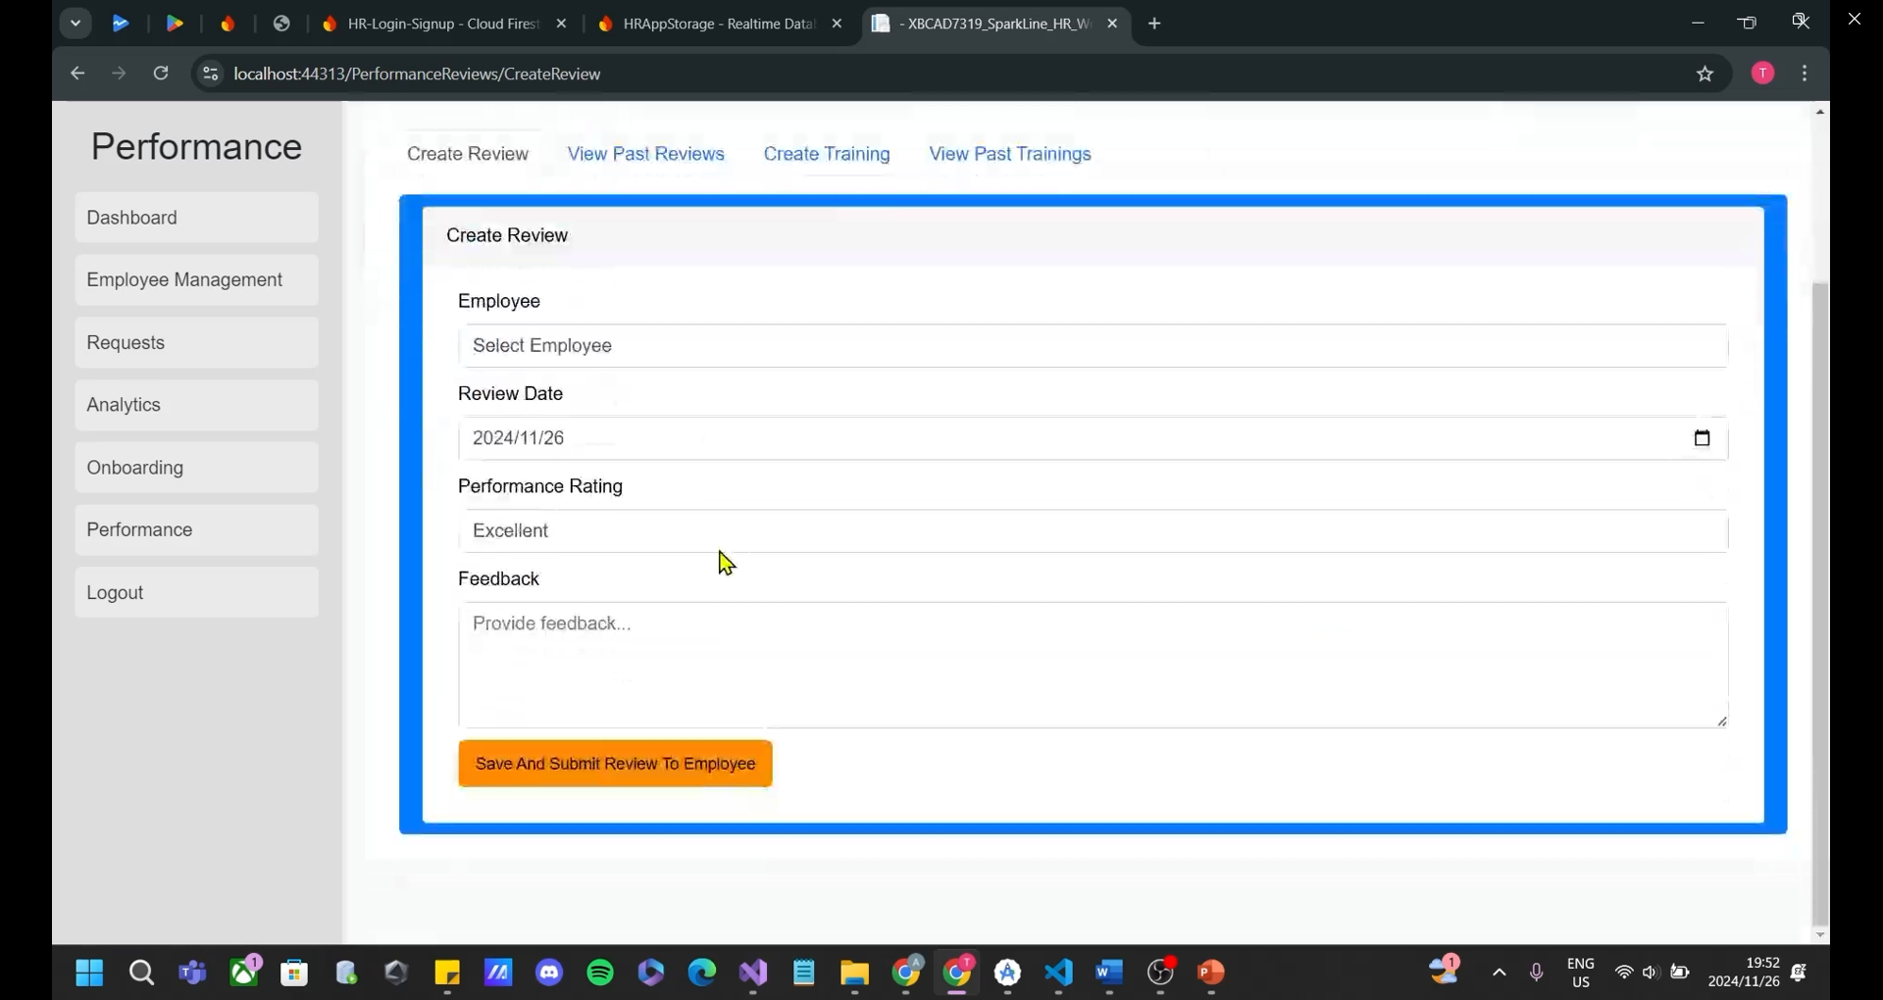

Figure 21: Performance - Create Review (SparkLine, 2024)

Figure 21: In the “Performance” screen, the HR can create reviews in the “Create Review” tab. Here, they can select an employee from the dropdown menu, select the date they are reviewing them on, select a performance rating from the dropdown menu and provide feedback to the employee regarding their review. Once done, the HR can click the “Save and Submit Review To Employee” button.

## List of Reviews

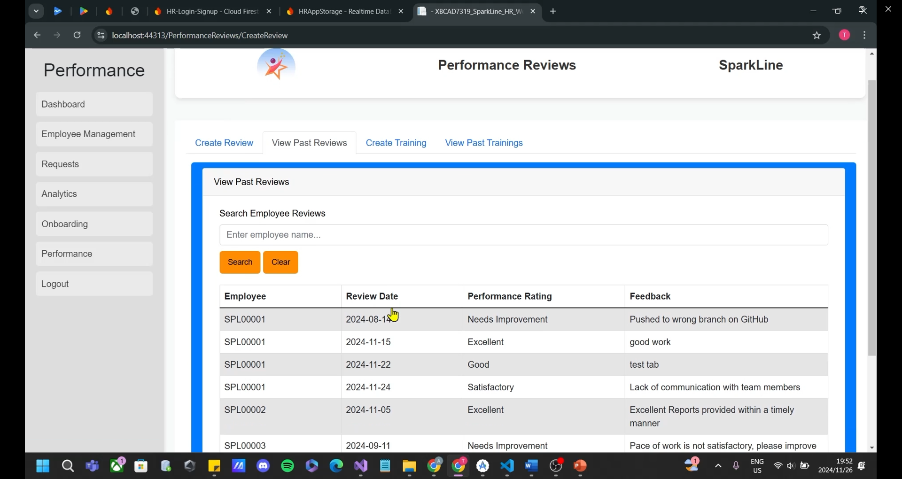

Figure 22: Performance - View Past Reviews (SparkLine, 2024)

Figure 22: In the “View Past Reviews” tab, the HR can search for an employee using their name to filter the list of all performance reviews conducted. They can also press the “Clear” button to clear the filter and show all performance reviews that have been conducted.

## Create Training

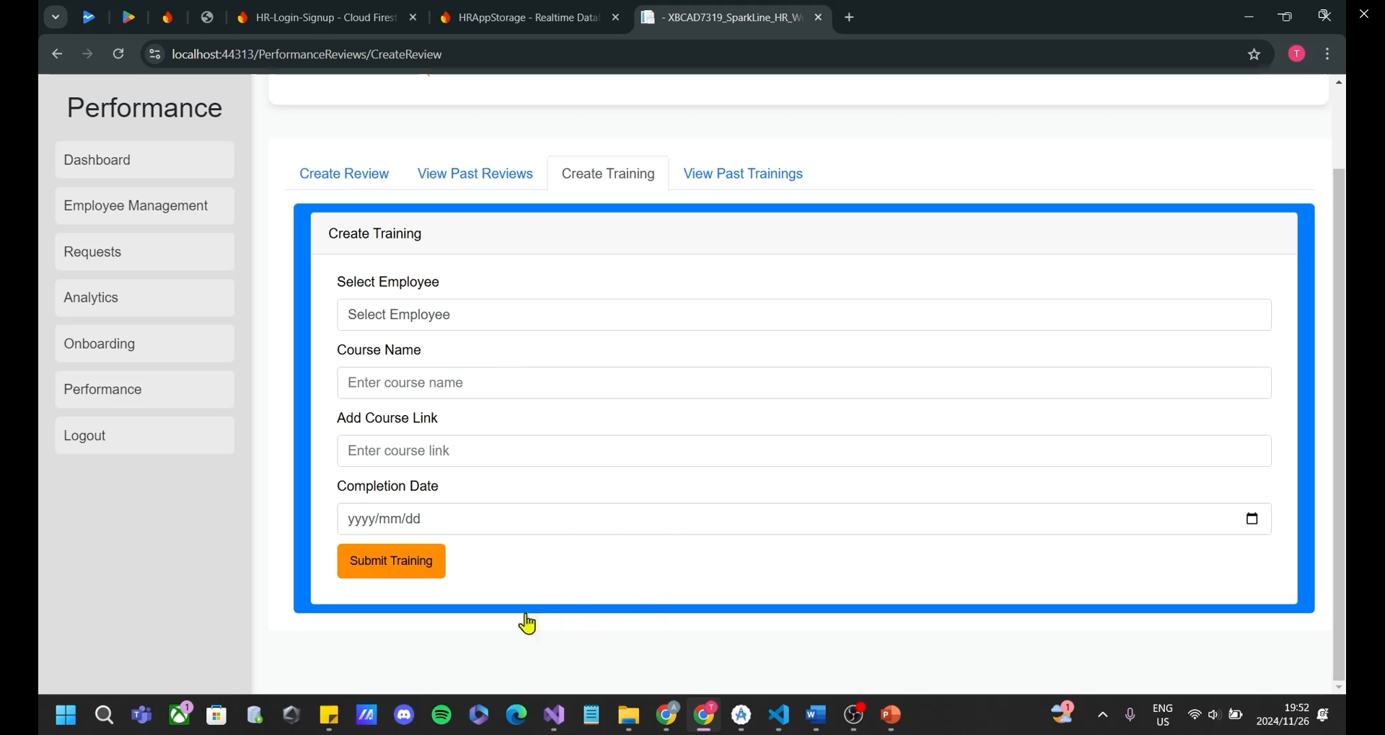

Figure 23: Performance - Create Training (SparkLine, 2024)

Figure 23: In the “Create Training” tab, the HR can select an employee to conduct the training, enter a course name, course link and the date at which the training should be completed by. Once done, the HR can click the “Submit Training” button.

## List of Trainings

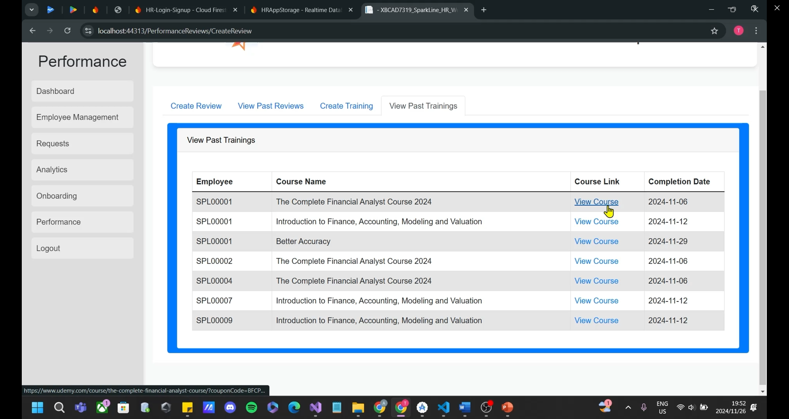

Figure 24: Performance - View Past Trainings (SparkLine, 2024)

Figure 24: In the “View Past Trainings” tab, the HR can view a list of all trainings conducted for which employee and on which date. If the HR wants to view it, they can click on the “View Course” hyperlink which will redirect them to the website of that particular course.

## Final Notes and Support

Thank you for choosing SparkLine HR! We hope this user manual has provided you with all the information you need to make the most of our application. Our team, *The A Team Developers,* has worked diligently to create a solution that enhances your experience and meets your needs effectively. Should you encounter any issues or have suggestions for improvement, please don’t hesitate to reach out.

**Contact Us**

* Email: the.a.team.bcad@gmail.com